# CS 255 System Design Document Template

## UML Diagrams

### UML Use Case Diagram

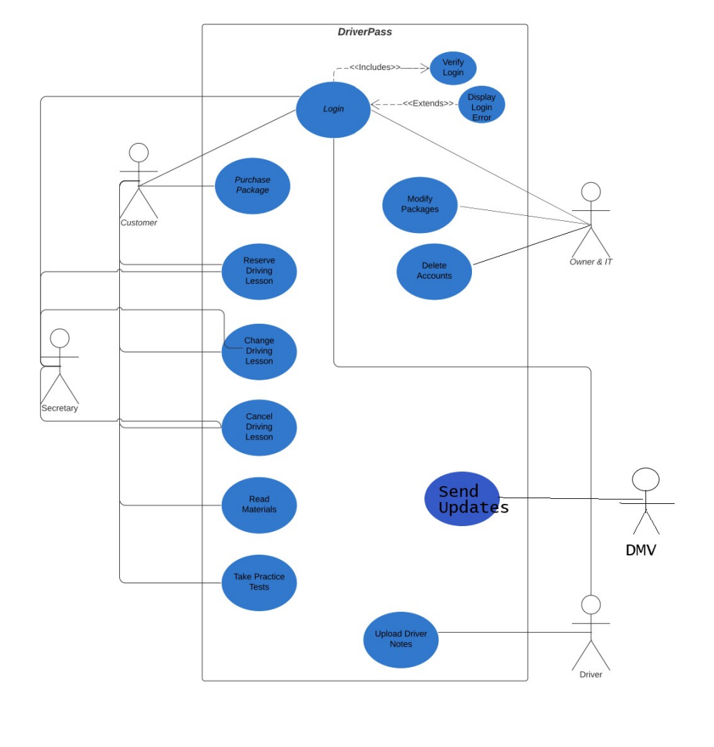

### UML Activity Diagrams

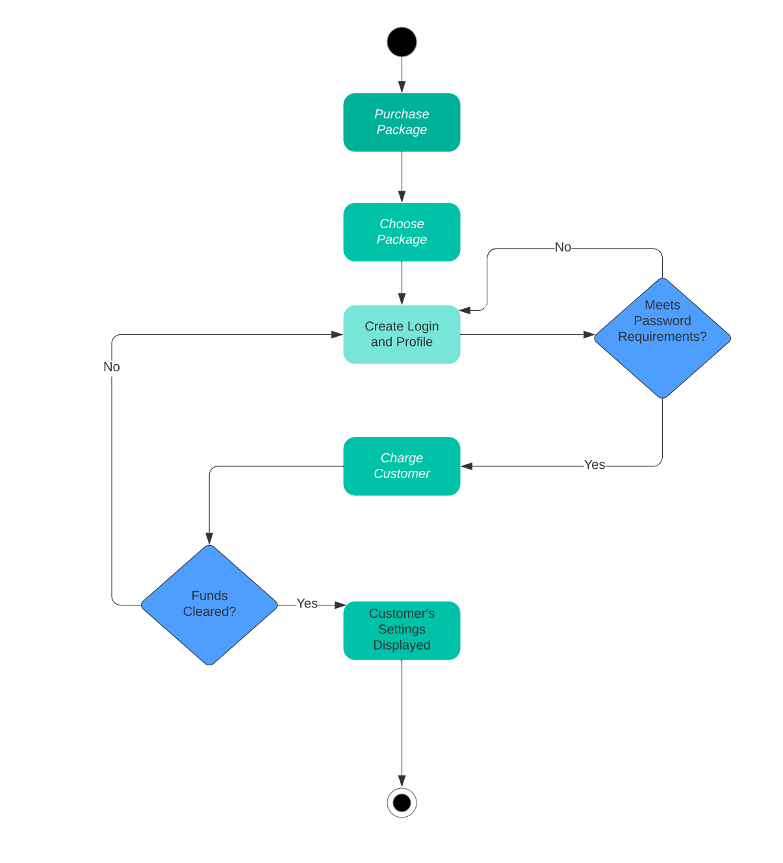

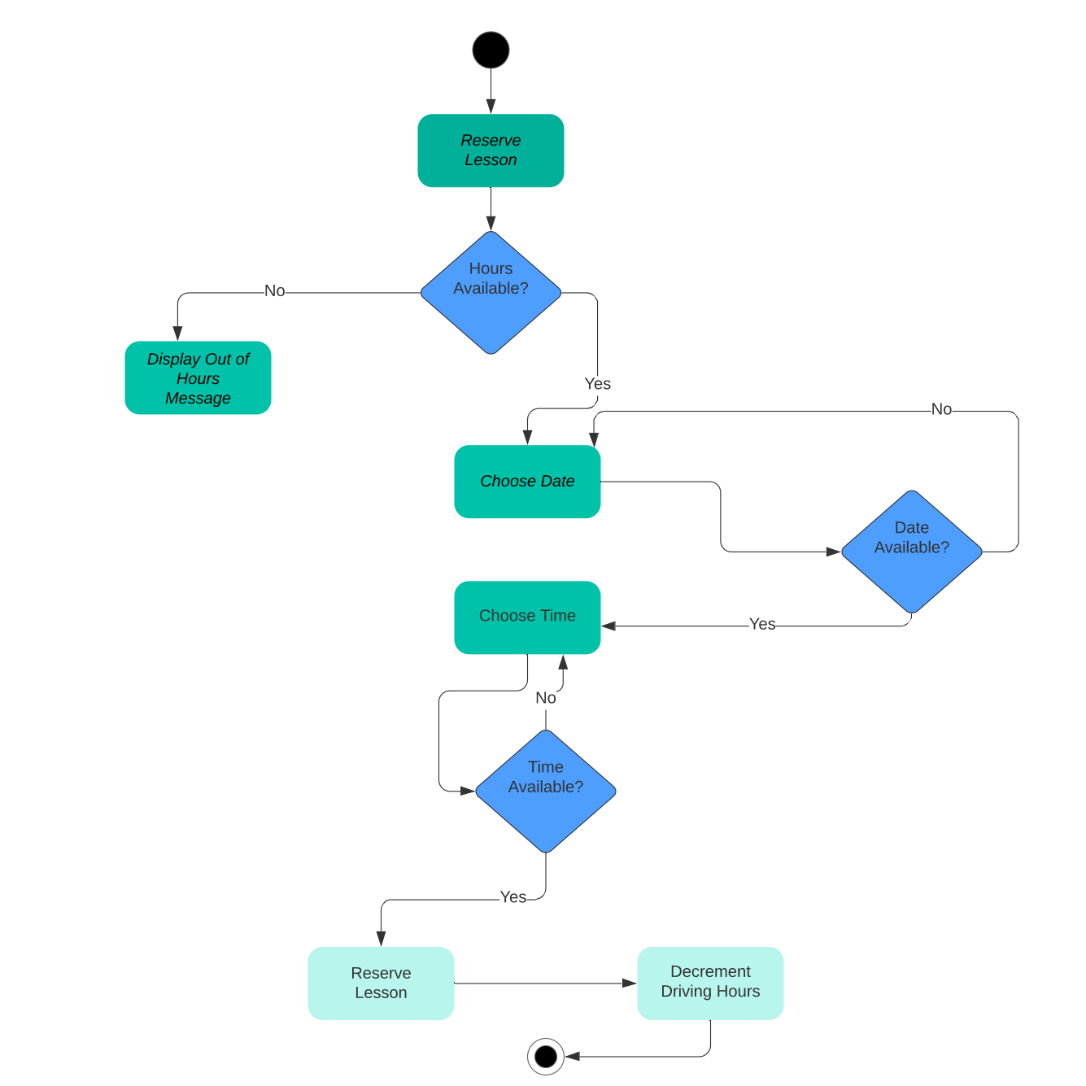

### UML Sequence Diagram

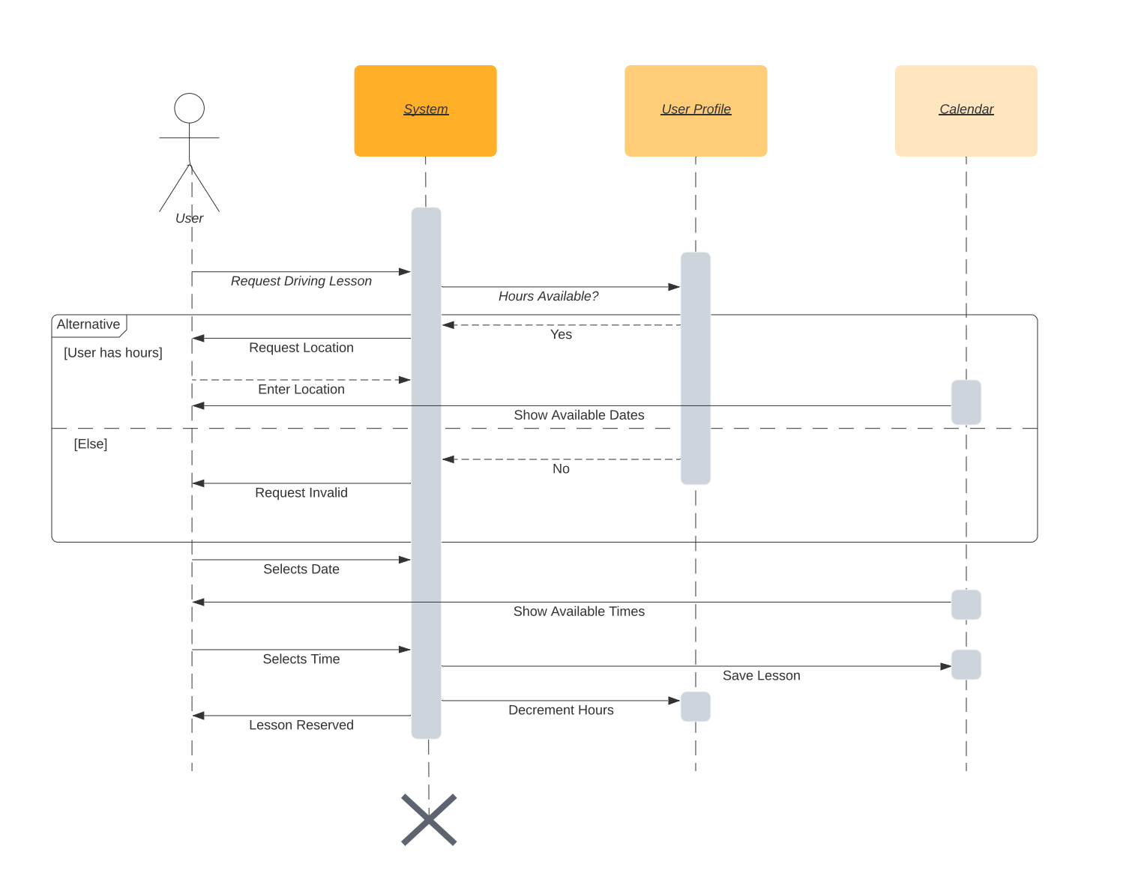

### UML Class Diagram

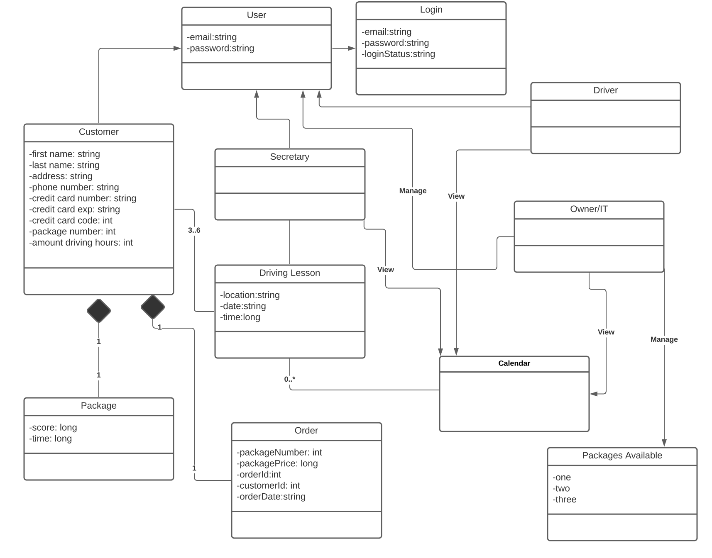

## Technical Requirements

The system requires a server to host the site, the particular server, however, will more than likely be determined by the cloud service provider. As for the client side, the chosen operating platform will help decide software and tools. With Linux, for example, free open-sourced software and tools can be used as well as free IDE’s that support many languages that are portable to other platforms. SSL and HTTPS will be used for secure logins and transactions; an encryption can be used for the contents in memory and storage for user’s personal data as well.